Ayan Basu

EID: ab73287

Dr. Yerraballi - Unique #17070

16 February 2021

***Lab 3 Deliverables***

***PART A - Circuit Diagram***

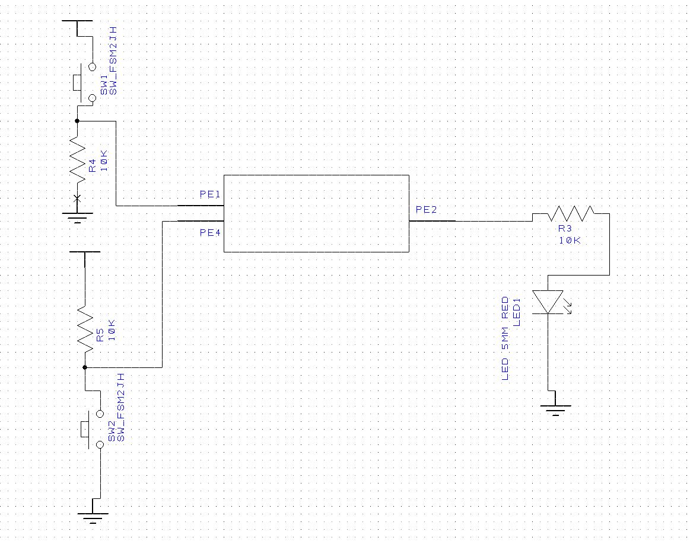

***PART B - Estimated LED Voltage & Current***

*Estimated Voltage Value (Vd)*: **Vd = 1.600170231 Volts**

*Estimated Current Value (Id)*: **Id = 3.4046175 Amperes**

R=470, find Id & Vd; → Ohm’s Law: Vd=Id*R; Vd=470Id → given equation in Lab Manual, Id=20*Vd - 32; Id = 20*(470Id) - 32 → Id = 0.0034046175 Amps → Id = 3.4046175 mAmps → Vd = Id * R → Vd = 3.4 * 470 → Vd = 1.600170231 Volts

***PART C - Debugging Screenshot***

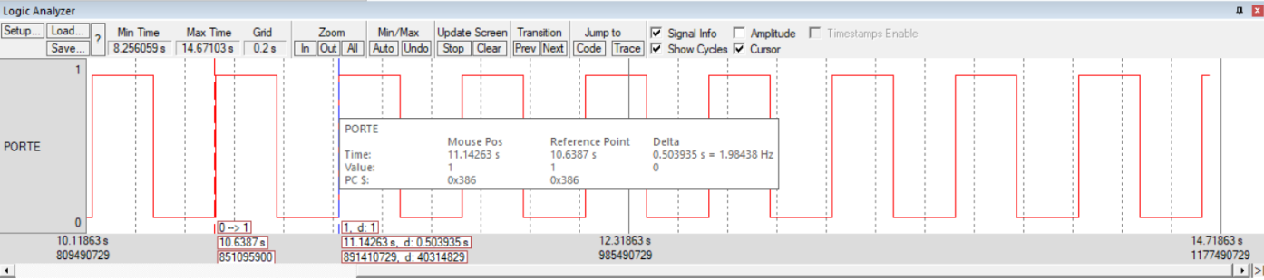

***PART D - Switch Measurements***

|  |  |  |  |
| --- | --- | --- | --- |
| Parameter | Value | Units | Conditions |
| Resistance of the  10kΩ resistor, R1 | 10000 | ohms | with power off and  disconnected from circuit  (measured with ohmmeter) |
| Supply Voltage, V+3.3 | 3.28 | volts | Powered  (measured with voltmeter) |
| Input Voltage, VPE1 | 0 | volts | Powered, but  with switch not pressed  (measured with voltmeter) |
| Resistor current | 0 | mA | Powered, but switch not pressed  I=VPE1/R1 (calculated and  measured with an ammeter) |
| Input Voltage, VPE1 | 3.28 | volts | Powered and  with switch pressed  (measured with voltmeter) |
| Resistor current | 0.000328 | mA | Powered and switch pressed  I=VPE1/R1 (calculated and  measured with an ammeter) |

***PART E - LED Measurements***

|  |  |  |  |  |
| --- | --- | --- | --- | --- |
| Row | Parameter | Value | Units | Conditions |
| 1 | Resistance of the  470Ω resistor, R19 | 470 | ohms | with power off and disconnected from circuit (measured with ohmmeter) |
| 3 | TM4C123 Output, *VPE2*  input to 470Ω | 0 | volts | with **PE2** = 0 (measured with voltmeter relative to ground). We call this *VOL* of the TM4C123. |
| 4 | LED a+, *Va+*  Bottom side of R19 (anode side of LED) | 0 | volts | with **PE2** = 0 (measured with voltmeter relative to ground). This measurement is also weird, because it too is floating. |
| 5 | LED voltage | 1.6 | volts | calculated as *Va+*- *Vk-* (*Vk* is ground). |
| 6 | LED current (off) | 0 | mA | calculated as (*VOL*- *Va+*)/R19 |
| 7 | TM4C123 Output, *VPE2*  input to 470Ω | 2.9 | volts | with **PE2** = 1 (measured with voltmeter relative to ground). We call this *VOH* of the TM4C123. We previously assumed this was 3.2V. |
| 8 | LED a+, *Va+*  Bottom side of R19 (anode side of LED) | 2.8 | volts | with **PE2** = 1 (measured with voltmeter relative to ground) |
| 9 | LED voltage | 1.62 | volts | calculated as *Va+*- *Vk -*(*Vk* is ground). |
| 10 | LED current (on) | 2.76 | mA | calculated as (*VOH* - *Va+*)/R19 |
| 11 | LED current (on) | 5.03 | mA | measured with an ammeter |
|  |  |  |  |  |